EXERCISE 10.2

Question 1:

From a point Q, the length of the tangent to a circle is 24 cm and the distance of Q from the centre is 25 cm. The radius of the circle is  
(a) 7 cm  
(b) 12 cm  
(c) 15 cm  
(d) 24.5 cm

Solution:

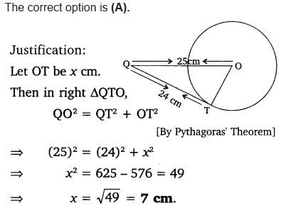

Question 2:

In figure, if TP and TQ are the two tangents to a circle with centre O so that ∠POQ = 110°, then ∠PTQ is equal to  
(a) 60°  
(b) 70°  
(c) 80°  
(d) 90°  
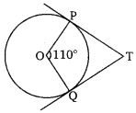

Solution:

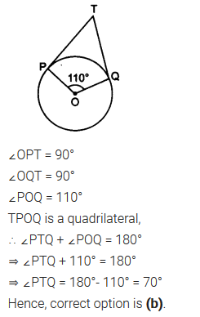

Question 3:

If tangents PA and PB from a point P to a circle with centre O are inclined to each other at angle of 80°, then ∠POA is equal to  
(a) 50°  
(b) 60°  
(c) 70°  
(d) 80°

Solution:

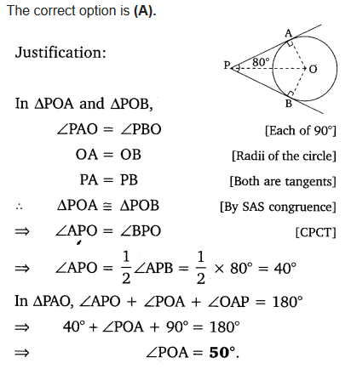

Question 4:

Prove that the tangents drawn at the ends of a diameter of a circle are parallel.

Solution:

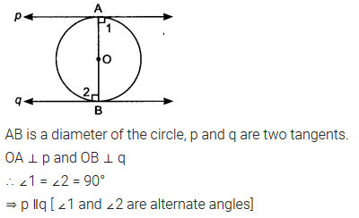

Question 5:

Prove that the perpendicular at the point of contact to the tangent to a circle passes through the centre.

Solution:

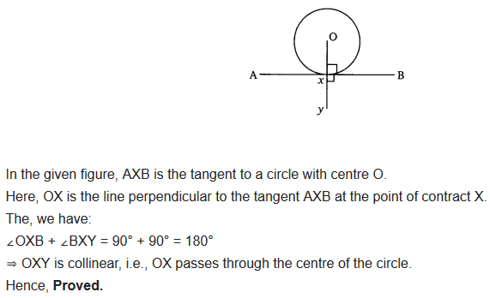

Question 6:

The length of a tangent from a point A at distance 5 cm from the centre of the circle is 4 cm. Find the radius of the circle.

Solution:

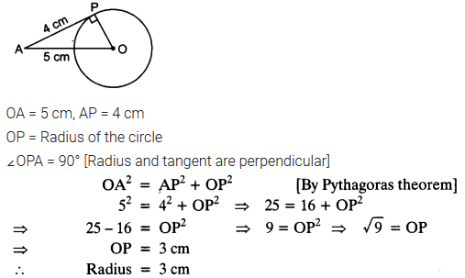

Question 7:

Two concentric circles are of radii 5 cm and 3 cm. Find the length of the chord of the larger circle which touches the smaller circle.

Solution:

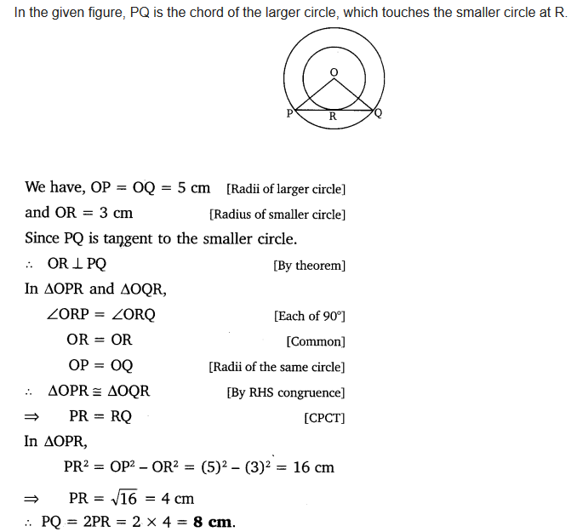

Question 8:

A quadrilateral ABCD is drawn to circumscribe a circle (see figure). Prove that AB + CD = AD + BC.  
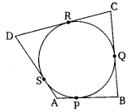

Solution:

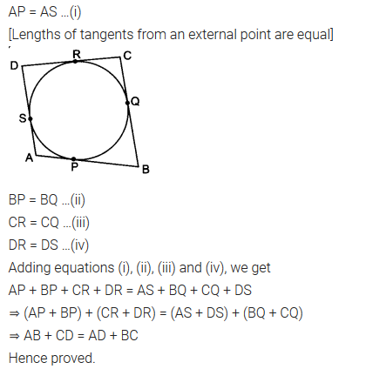

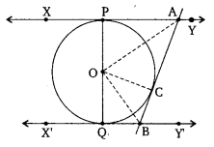Question 9:

In figure, XY and X’Y’ are two parallel tangents to a circle , x with centre O and another tangent AB with point of contact C intersecting XY at A and X’Y’ at B. Prove that ∠AOB = 90°.

Solution:

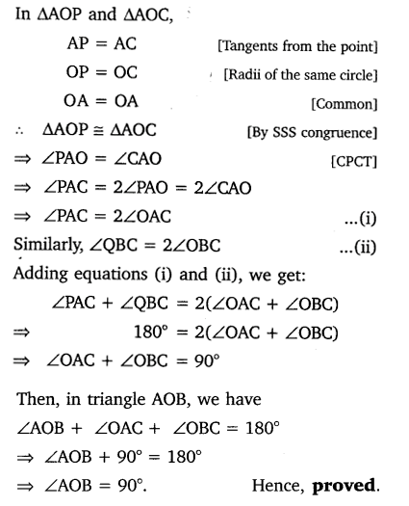

Question 10:

Prove that the angle between the two tangents drawn from an external point to a circle is supplementary to the angle subtended by the line segment joining the points of contact at the centre.

Solution:

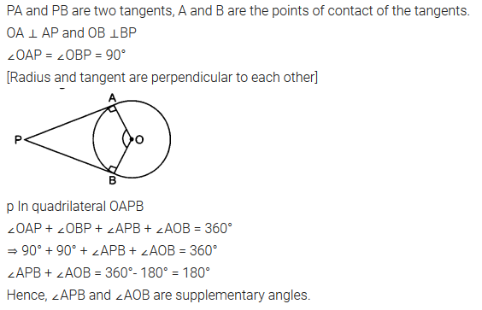

Question 11:

Prove that the parallelogram circumscribing a circle is a rhombus.

Solution:

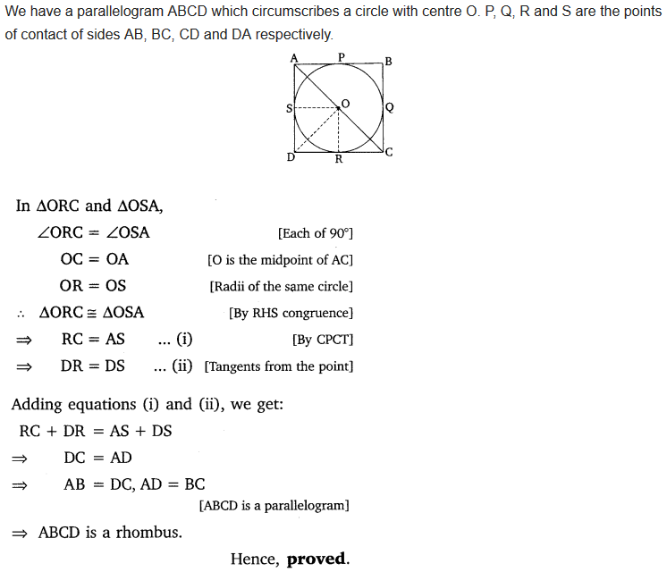

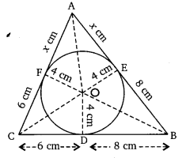Question 12:

A triangle ABC is drawn to circumscribe a circle of radius 4 cm such that the segments BD and DC into which BC is divided by the point of contact D are of lengths 8 cm and 6 cm respectively (see figure). Find the sides AB and AC.

Solution:

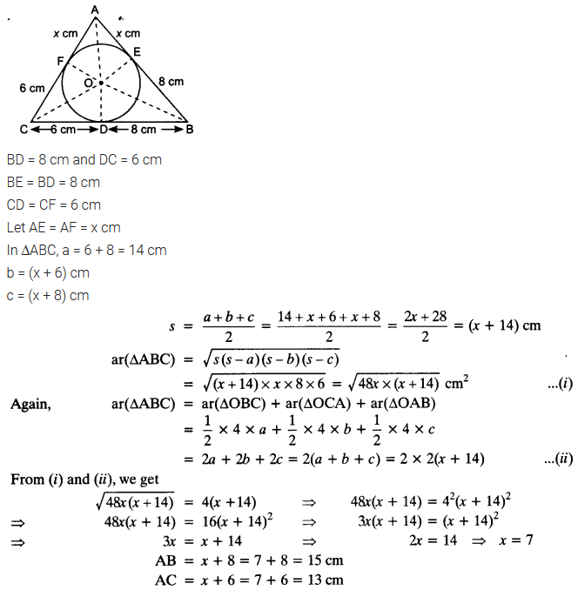

Question 13:

Prove that opposite sides of a quadrilateral circumscribing a circle subtend supplementary angles at the centre of the circle.

Solution:

